Name – Pallavi Chaudhary

Student Code – AF0316472

Batch Code – ANP-C6008

**Assignment 1**

1. write HTML code to create a Student Registration form.

HTML Code: -

<html>

    <head>

    <link href="form1.css" rel="Stylesheet">

    <title>

    Student's registration Form

    </title>

    </head>

    <body>

<div id = "form2">STUDENT REGISTRATION FORM</div><br>

<div id = "info">Basic Information</div><br>

<form>

<div id="full"> Full Name </div><br>

<div id="name">

<div id="First"><label>First Name</label></div>

<div id="first"><input type = "text" value="Enter First Name"></div>

<div id="middle"><label>Middle Name</label></div>

<div id="Middle" ><input type = "text" value="Enter Middle Name"></div>

<div id="Last"><label>Last Name</label></div>

<div id="last" ><input type = "text" value="Enter Last Name"></div>

</div><br>

<label id="DOB">Date of Birth</label><br><br>

<input type="date" value="MM/DD/YYYY"><br><br>

<label id="gen">Gender</label><br><br>

<input list='scr'><br>

<datalist id='scr'>

    <option value="Male">

    <option value="Female">

</datalist><br>

<div id="Add">Address</div><br>

<input type="Address" value="Street Address"><br><br>

<input type="Address" value="Street Address Line 2"><br><br>

<input type="Address" value="City"><br><br>

<input type="Address" value="Region"><br><br>

<input type="Address" value="Pin Code"><br><br>

<label id = "num">Student Number</label><br><br>

<input type="number" value="e.g. 123456"><br><br>

<label id= "year">Year Level</label><br><br>

<input type="number" value="Please Enter"><br>

<div id="A.Y.">for incoming A.Y. "12-"13</div><br>

<label id="Degree">Degree Program</label><br><br>

<input type="text" id="Degree" required name='section' list='scripts'><br>

<datalist id='scripts'>

    <option value ='BCA'>

    <option value='BBA'>

    <option value='B.tech'>

</datalist><br>

<label id="email">Email</label><br><br>

<input type="email" value="ex: myname@gmail.com" required><br>

</form>

<input type="button" value="Submit" onclick="submission()">

 <script>

     function submission(){

    document.write("Your form has been submitted")

    }

 </script>

    </body>

</html>

CSS Code: -

#form2{

    font-size: 60px;

    text-align: center;

    color: rgb(4, 4, 4);

    word-spacing: 20px;

}

#info{

    color: rgb(21, 18, 18);

    font-weight: bold;

    padding: 20px;

    background-color: rgb(185, 185, 158);

}

#full,#DOB,#gen,#Add,#num,#year,#Degree,#email{

color: rgb(8, 7, 7);

}

#name{

    padding:5px;

    margin:5px;

}

Output: -

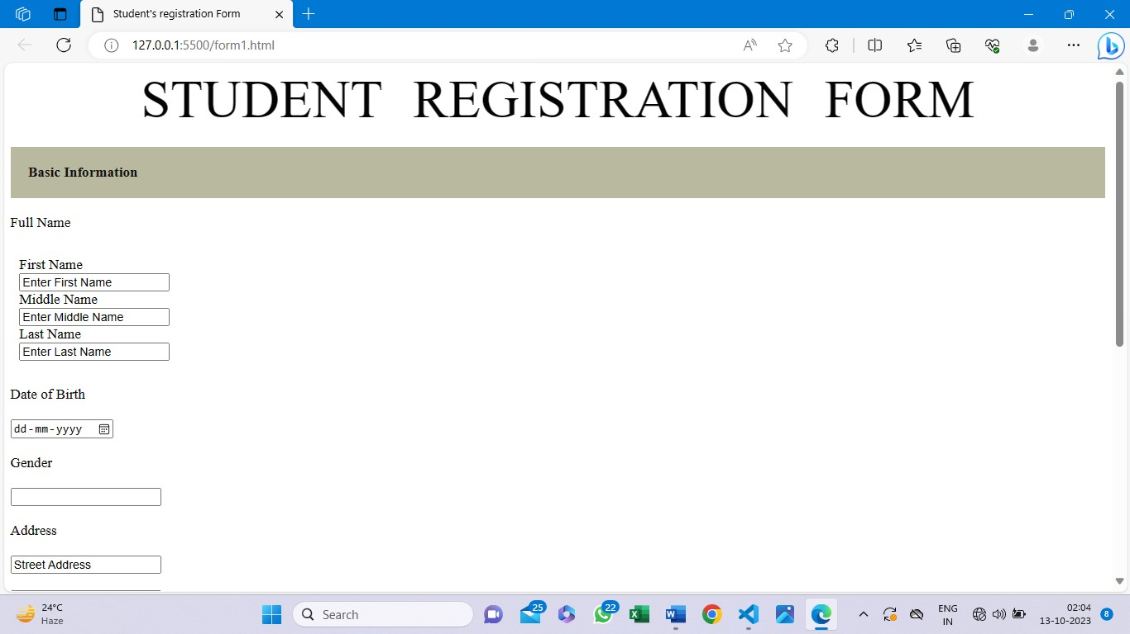

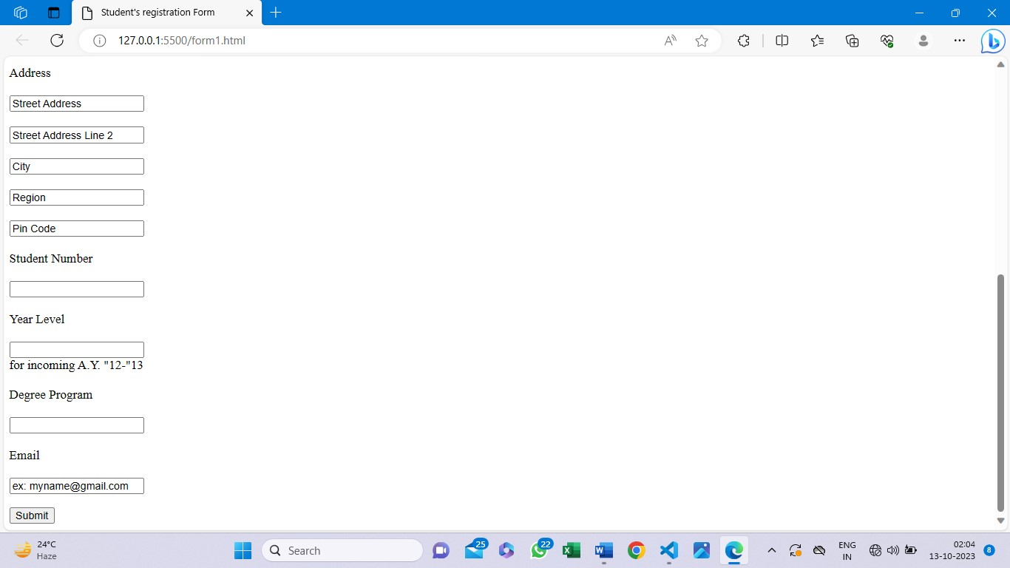

1. Write HTML code for creating Web page containing multiple MCQs.

HTML Code: -

<html>

    <head>

        <title>

            MCQ website

        </title>

    </head>

    <body>

        <h1>MCQ Questions</h1>

        <div>1. What does the abbreviation HTML stand for?</div>

        <br><button>HyperText Markup Language.</button>

        <br><button>HighText Markup Language.</button>

        <br><button>HyperText Markdown Language.</button>

        <br><button>None of the above.</button><br>

        <br><div>2. How many sizes of headers are available in HTML by default?</div>

        <br><button>5</button>

        <br><button>1</button>

        <br><button>3</button>

        <br><button>6</button><br>

        <br><div>3. What is the smallest header in HTML by default?</div>

        <br><button>h1</button>

        <br><button>h2</button>

        <br><button>h6</button>

        <br><button>h4</button><br>

        <br><div>4. What are the types of lists available in HTML?</div>

        <br><button>Ordered, Unordered Lists.</button>

        <br><button>Bulleted, Numbered Lists.</button>

        <br><button>Named, Unnamed Lists.</button>

        <br><button>None of the above.</button><br>

        <br><div>5. HTML files are saved by default with the extension?</b></div>

        <br><button>.html</button>

        <br><button>.h</button>

        <br><button>.ht</button>

        <br><button>None of the above</button><br>

        <br><button>Submit</button>

    </body>

</html>

Output: -

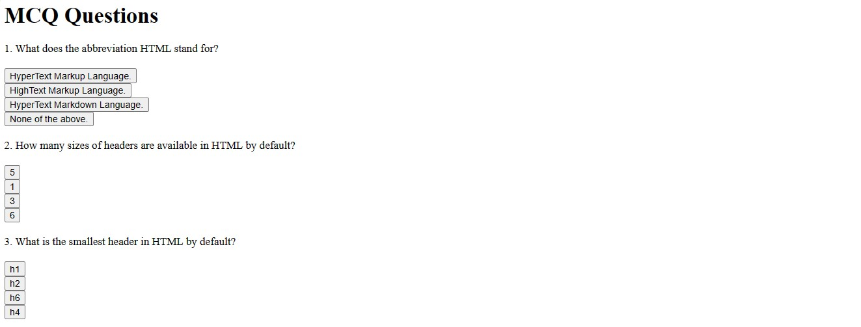

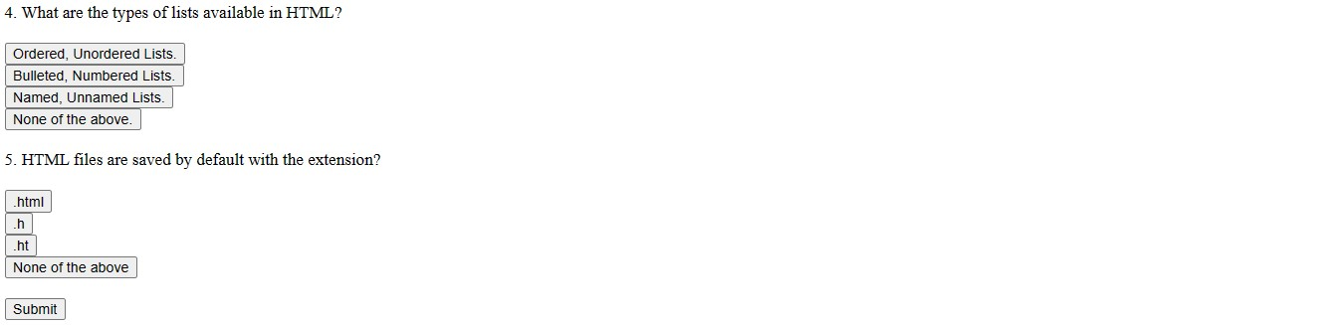

1. Divide HTML into different frames and display different web page in those frames.

HTML Code: -

Our code for frame 1

<html>

    <head>

        <title>

            Frame 1

        </title>

    </head>

    <body>

        <h1>Frame One</h1>

    </body>

</html>

Our code for frame 2

<html>

    <head>

        <title>

            Frame 2

        </title>

    </head>

    <body>

        <h1>Frame Two</h1>

    </body>

</html>

Now, dividing the website into two frames

<html>

<head>

    <title>

Dividing website into frames

    </title>

    <frameset cols = "50%,50%">

    <frame src="frame1.html">

    <frame src="frame2.html">

    </frameset>

</head>

</html>

Output: -

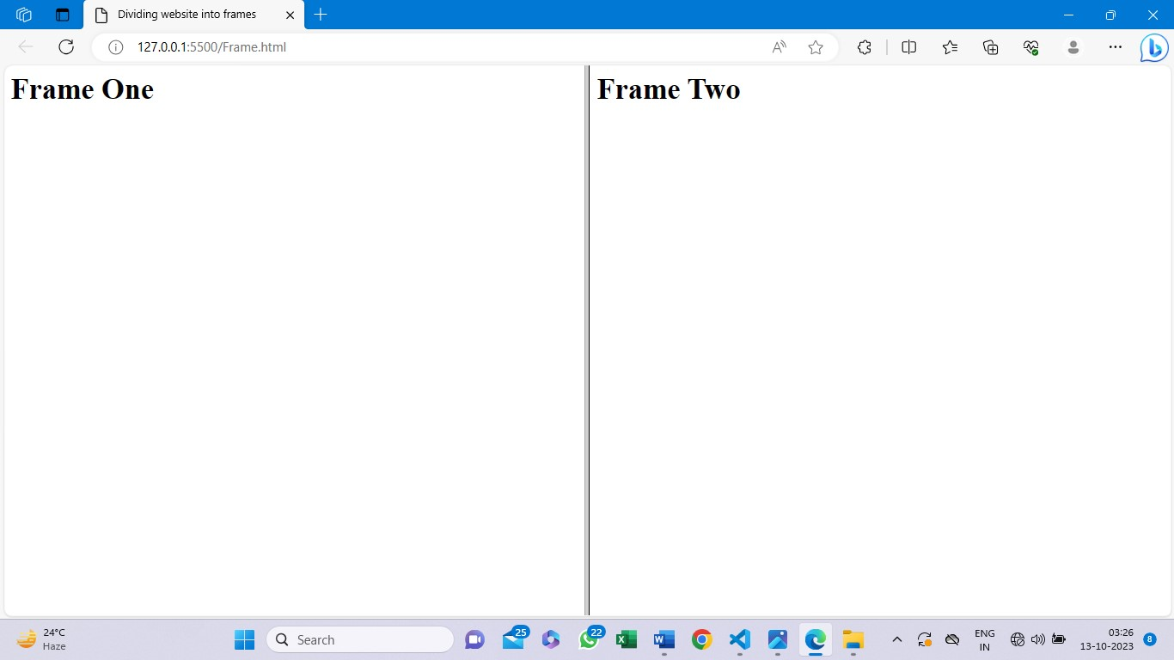

4) Create a mini calculator using java script, HTML and CSS.

Code: -

<html>

    <head>

        <title>

            Calculator

        </title>

    </head>

    <body style = "background-color: rgb(205, 174, 179);">

    <h3 style = "font-size : 30px;">Calculator</h3>

<!-- ===================================================================================================================== -->

        <label>Enter Number 1</label>

        <!-- taking input from the user for performing calculation -->

        <input id="No1" type="number" style="text-align: center;">

        <br><br>

        <label >Enter Number 2</label>

        <!-- taking input from the user for performing calculation -->

        <input id="No2" type="number" style = "text-align : center">

        <br><br>

        <!-- displaying Addition -->

        <input type="button" value="+" onclick="Add()" style = "text-align : center"><br>

        <p id="add"></p>

        <!-- displaying Subtraction -->

        <input type="button" value="-" onclick="Sub()" style = "text-align : center"><br>

        <p id="sub"></p>

        <!-- displaying Multiplication -->

        <input type="button" value="x" onclick="Mul()" style = "text-align : center"><br>

        <p id="mul"></p>

        <!-- displaying Division -->

        <input type="button" value="/" onclick="Div()" style = "text-align : center"><br>

        <p id="div"></p>

        <!-- displaying Modulous -->

        <input type="button" value="%" onclick="Mod()" style = "text-align : center"><br>

        <p id="mod"></p>

<!-- ===================================================================================================================== -->

        <Script>

           function Add()

           {

           var x=Number(document.getElementById("No1").value);

           var y=Number(document.getElementById("No2").value);

           if(x==""||y==""){

            alert("Enter the numbers first");

           }

           var z=x+y;

           document.getElementById("add").innerHTML= +x+" + "+y+" = "+z;

           }

           function Sub(){

           var x=Number(document.getElementById("No1").value);

           var y=Number(document.getElementById("No2").value);

           if(x==""||y==""){

            alert("Enter the numbers first");

           }

           var a=x-y;

           document.getElementById("sub").innerHTML= +x+" - "+y+" = "+a;

           }

           function Mul(){

            var x=Number(document.getElementById("No1").value);

            var y=Number(document.getElementById("No2").value);

           if(x==""||y==""){

           alert("Enter the numbers first");

           }

           var k=x*y;

           document.getElementById("mul").innerHTML= +x+" x "+y +" = " +k;

           }

           function Div(){

            var x=Number(document.getElementById("No1").value);

            var y=Number(document.getElementById("No2").value);

            if(x==""||y==""){

            alert("Enter the numbers first");

           }

           var o = x/y;

           document.getElementById("div").innerHTML=  +x+" / " +y+ " = " +o ;

           }

           function Mod(){

            var x=Number(document.getElementById("No1").value);

            var y=Number(document.getElementById("No2").value);

            if(x==""||y==""){

            alert("Enter the numbers first");

           }

           var r=x%y;

           document.getElementById("mod").innerHTML= x+ " % " +y+ " = " +r;

           }

         </Script>

    </body>

</html>

Output: -

